**Exercise 3**

In the previous exercise (2) we calculated the artificial columns {Clarity, Politeness, Satisfaction} for each entry in the data.

In the current exercise we filtered the data, leaving in only subjects with the ages of 18-49. We also filtered out the NA rows from the data.

**Part 1**:

For this section we split the data in two ways: (1) By System {S, C} (2) By Sex {C1, C2} Where S stands for "Software", C for "Social Systems", C1 for "Male" and C2 for "Female". Then we have conducted two unpaired t-tests for comparing two groups by their Politeness as follows:

Normality test for the groups using Shapiro's tests and QQ-plots revealed that group System=S seemed not normally distributed nor the group Sex=C2 ("Female").

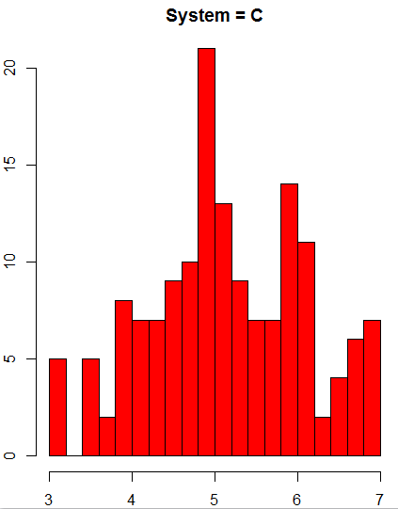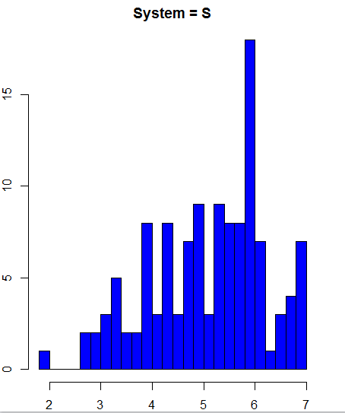

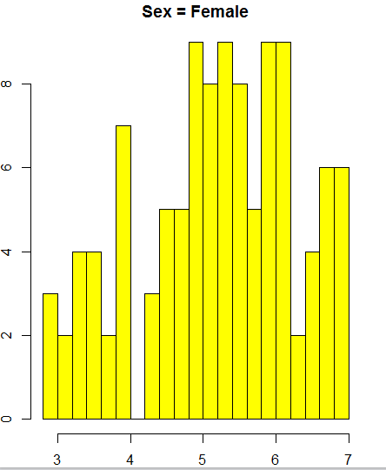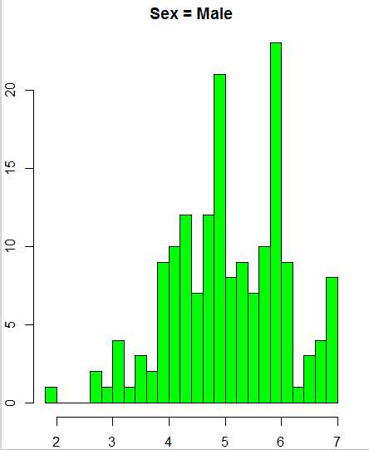

Histograms for each group

Constant variance test (F test) between each pair of the groups (1) and (2) revealed that groups (1) have unequal variance where groups (2) have equal variance with p-values equal to 0.04164 and 0.3928 respectively.

Test 1 for comparing the groups (1):

We performed unpaired t-test with unequal variance and got the following results:

As we can see from the results we cannot reject which means that the factor System has no significant impact on Politeness.

Test 2 for comparing the groups (2):

We performed unpaired t-test with equal variance and got the following results:

As we can see from the results we cannot reject which means that the factor Sex has no significant impact on Politeness.

**Part 2:**

In this section we conducted a two-way ANOVA with the input:

We have groups according to the possible combinations of the two factors: .

Descriptive statistics:

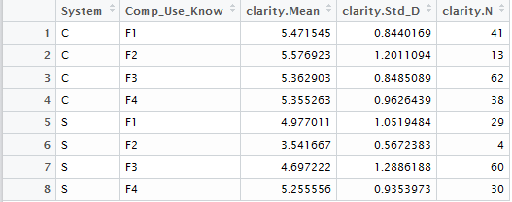

In order to test if the variance is constant we performed Levene's test and get the following results:

Df Sum Sq Mean Sq F value Pr(>F)

data_filtered$clarity 1 2.06 2.0592 5.899 0.0158 *

Residuals 275 95.99 0.3491

---

Signif. codes: 0 ‘***’ 0.001 ‘**’ 0.01 ‘*’ 0.05 ‘.’ 0.1 ‘ ’ 1

P-value is less than 0.05 therefore we reject the null hypothesis where we have a constant variance.

Giving this situation we used a significance level of 0.01 instead of 0.05 in the two-way ANOVA. (Theoretically we should be performing here a-parametric test like B-F and Welch ANOVA fixes).

We get the following results from the two-way anova:

Df Sum Sq Mean Sq F value Pr(>F)

System 1 20.4 20.402 19.649 1.36e-05 ***

Comp_Use_Know 3 3.8 1.265 1.219 0.3033

System:Comp_Use_Know 3 10.6 3.535 3.404 0.0182 *

Residuals 269 279.3 1.038

---

Signif. codes: 0 ‘***’ 0.001 ‘**’ 0.01 ‘*’ 0.05 ‘.’ 0.1 ‘ ’ 1

As it can be seen in the results, the factor System is strongly significant which means that it's impact is very high on Clarity.

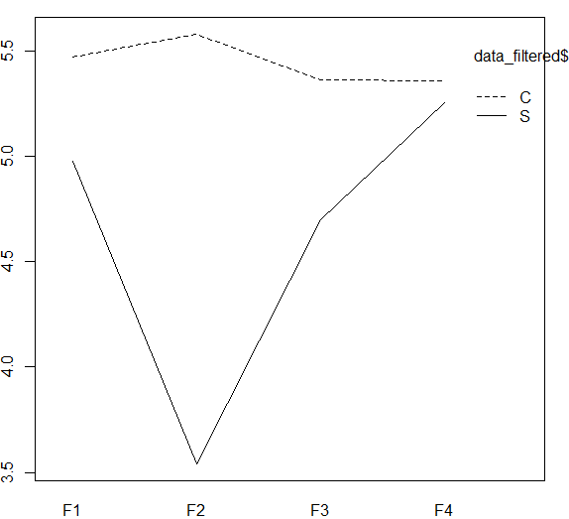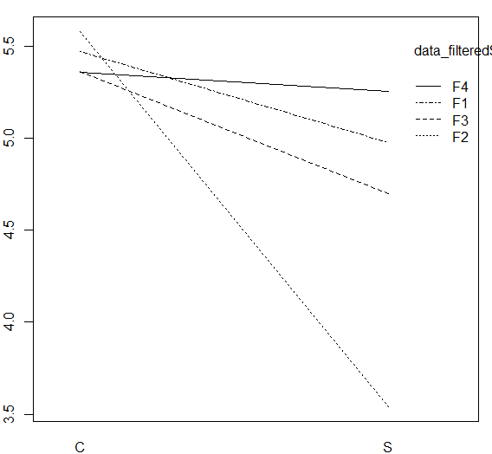We cannot conclude that there is an interaction between System and Comp_Use_Know because we use a significant level of 0.01.

According to the interaction plots we see some possible interaction between System and Comp_Use_Know. However, the results from the two-way ANOVA show that this is not sufficient for the significance level of 0.01.

Because the p-value of the interaction variable is close to 0.01 we decided to do an interaction effects analysis using the following 6 tests:

1. One-way ANOVA of Clarity~Comp_Use_Know where System = "S".

Df Sum Sq Mean Sq F value Pr(>F)

Comp_Use_Know 3 13.63 4.544 3.482 0.0181 *

Residuals 119 155.30 1.305

---

Signif. codes: 0 ‘***’ 0.001 ‘**’ 0.01 ‘*’ 0.05 ‘.’ 0.1 ‘ ’ 1

1. One-way ANOVA of Clarity~Comp_Use_Know where System = "C".

Df Sum Sq Mean Sq F value Pr(>F)

Comp_Use_Know 3 0.77 0.2561 0.31 0.818

Residuals 150 124.01 0.8267

1. T-test of Clarity~System where Comp_Use_Know = "F1".

t = 2.0985, df = 51.788, p-value = 0.04075

95 percent confidence interval:

0.02161104 0.96745540

1. T-test of Clarity~System where Comp_Use_Know = "F2".

t = 4.6519, df = 11.51, p-value = 0.0006234

95 percent confidence interval:

1.077491 2.993022

1. T-test of Clarity~System where Comp_Use_Know = "F3".

t = 3.3584, df = 101.6, p-value = 0.001104

95 percent confidence interval:

0.2725097 1.0588523

1. T-test of Clarity~System where Comp_Use_Know = "F4".

t = 0.43086, df = 63.161, p-value = 0.668

95 percent confidence interval:

-0.3627115 0.5621267

The results we got from the 6 tests match the interaction plots.

From the first two One-way ANOVA tests we conclude the following:

When System = "S" the value of Comp_Use_Know effect Clarity significantly with p-value = 0.0181. This result can be seen visually on the left interaction plot where the values of Clarity for each value of Comp_Use_Know are highly distinct. When System = "C" those values are more close to each other which means that Comp_Use_Know has less effect power on Clarity.

From the later four t-tests we conclude the following:

When Comp_Use_Know = F2 the t-test results show that p-value is very small which can be seen on the right interaction plot as the large difference between Clarity values of System = "S" and System = "C". This is also true for F1,F3 but with less effect on Clarity. In fact, the value of the p-values is correlated to the size of the difference of the Clarity values on the interaction plot for each Comp_Use_Know value.

When Comp_Use_Know = F4 the t-test results are not significant which can be seen on the plot as the smallest difference on Clarity between the two systems.

Finally, we performed three post-hoc Scheffe tests in order to find out if there are differences between each two values of the factor Comp_Use_Know as follows:

clarity std r Min Max

F1 5.266667 0.9603240 70 2.166667 7

F2 5.098039 1.3907667 17 2.833333 7

F3 5.035519 1.1332745 122 2.000000 7

F4 5.311275 0.9449633 68 2.666667 7

alpha: 0.05 ; Df Error: 269

Critical Value of F: 2.638161

Means with the same letter are not significantly different.

Groups, Treatments and means

a F4 5.311

a F1 5.267

a F2 5.098

a F3 5.036

clarity std r Min Max

F1 4.977011 1.0519484 29 2.166667 6.166667

F2 3.541667 0.5672383 4 2.833333 4.000000

F3 4.697222 1.2886188 60 2.000000 7.000000

F4 5.255556 0.9353973 30 2.666667 7.000000

alpha: 0.05 ; Df Error: 119

Critical Value of F: 2.680811

Means with the same letter are not significantly different.

Groups, Treatments and means

a F4 5.256

a F1 4.977

a F3 4.697

a F2 3.542

clarity std r Min Max

F1 5.471545 0.8440169 41 3.333333 7

F2 5.576923 1.2011094 13 3.833333 7

F3 5.362903 0.8485089 62 3.000000 7

F4 5.355263 0.9626439 38 3.333333 7

alpha: 0.05 ; Df Error: 150

Critical Value of F: 2.664907

Groups, Treatments and means

a F2 5.577

a F1 5.472

a F3 5.363

a F4 5.355

As we can see there are no significant differences between the factor values according to because each value ended up in the same group a.

**Conclusions:**

From the interaction plots and the two-way ANOVA results we conclude that System=C has significantly higher Clarity from System=S.